Case Study - Employee Analytics System

Master Tables
create database employeeAnalytics;

use employeeAnalytics;

create table Departments(
dept_id int primary key,
dept_name varchar(50) not null unique
);

create table Locations(
location_id int primary key,
locatio_name varchar(50) not null unique
);

create table Job_Roles(
role_id int primary key,
role_name varchar(50) not null,
min_salary decimal(10,2),
max_salary decimal(10,2)
);

Employee Table

create table employees(
emp_id int primary key,
emp_name varchar(100) not null,
gender varchar(10),
dept_id int,
role_id int,
location_id int,
join_date date,
status varchar(20) default 'Active',
Foreign key(dept_id) references Departments(dept_id),
Foreign key(role_id) references Job_Roles(role_id),
Foreign key(location_id) references Locations(location_id)
);
Salary table

create table Salaries(
salary_id int primary key,
emp_id int,
salary decimal(10,2),
effective_date date,
foreign key(emp_id) references employees(emp_id)
);

Performance Table

create table Performance_Reviews(
review_id int primary key,
emp_id int,
review_year int,
rating decimal(2,1) check(rating between 1 and 5),
foreign key(emp_id) references employees(emp_id)
);

Insert into Departments values(
(1,’IT’),
(2,’HR’),
(3,’Finance’),
(4,’Marketing’),
(5,’Operations’));

Importing data

BULK INSERT Departments
FROM 'D:\Departments.csv'
WITH (
FIRSTROW = 2,
FIELDTERMINATOR = ',',
ROWTERMINATOR = '\n',
TABLOCK
);
BULK INSERT Locations
FROM 'D:\Locations.csv'
WITH (
FIRSTROW = 2,
FIELDTERMINATOR = ',',
ROWTERMINATOR = '\n',
TABLOCK
);
BULK INSERT Job_Roles
FROM 'D:\job_roles.csv'
WITH (
FIRSTROW = 2,
FIELDTERMINATOR = ',',
ROWTERMINATOR = '\n',
TABLOCK
);
BULK INSERT employees
FROM 'D:\employees.csv'
WITH (
FIRSTROW = 2,
FIELDTERMINATOR = ',',
ROWTERMINATOR = '\n',
TABLOCK
);
BULK INSERT Salaries
FROM 'D:\salaries.csv'
WITH (
FIRSTROW = 2,
FIELDTERMINATOR = ',',
ROWTERMINATOR = '\n',
TABLOCK
);
BULK INSERT Performance_reviews
FROM 'D:\Performance_reviews.csv'
WITH (
FIRSTROW = 2,
FIELDTERMINATOR = ',',
ROWTERMINATOR = '\n',
TABLOCK
);

Performance Analytics

1.Top 10 high performing employees

This query calculates the average performance rating for each employee and then selects the top 10 employees with the highest average ratings.

Query

select top 10 e.emp_id ,e.emp_name,avg(pr.rating) as Average_Rating
from employees e join Performance_Reviews pr on
e.emp_id = pr.emp_id
group by e.emp_id,e.emp_name
order by avg(pr.rating) desc;

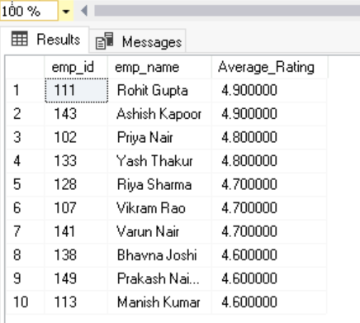

2.Average rating per department

This query calculates the average performance rating of active employees in each department.
It then lists all departments sorted from the highest to lowest average rating.

Query

select d.dept_id,d.dept_name,round(avg(pr.rating),2) as Average_Rating from Departments d join employees e
on e.dept_id=d.dept_id
join Performance_Reviews pr
on e.emp_id=pr.emp_id
where e.status='Active'
group by d.dept_id,d.dept_name
order by avg(pr.rating) desc;

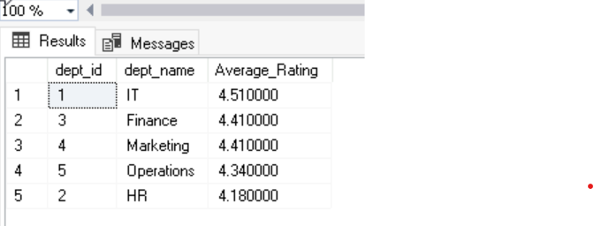

3.Employees eligible for promotion(rating>4 & 2+ years)

This query retrieve data of employees who is eligible for promotion using the conditions that their performance rating is more than 4 and had 2 + years of experience

Query

select e.emp_id,e.emp_name,pr.rating from employees e
join Performance_Reviews pr
on e.emp_id =pr.emp_id
where pr.rating>4 and
datediff(year, e.join_date, getdate()) >= 2;

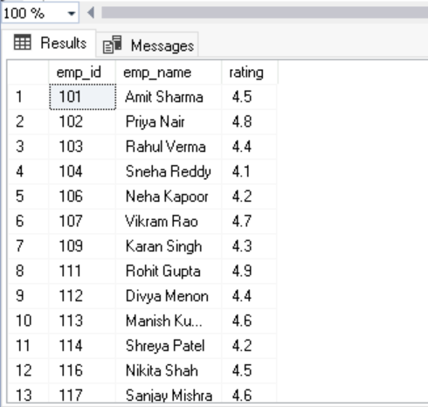

4.performance trend over years

The query returns the average rating per year in order to find trend over the years.

Query

select
review_year,
AVG(rating) AS avg_rating
from Performance_Reviews
group by review_year
order by review_year;

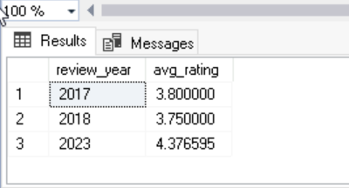

Salary Analytics

5.Salary distribution per department

This query returns the average salary per department to show the salary distribution per department.

Query

select d.dept_id,d.dept_name,avg(s.salary) as Average_Salary
from Departments d join
employees e
on e.dept_id=d.dept_id
join salaries s
on s.emp_id=s.emp_id
group by d.dept_id,d.dept_name
order by Average_Salary;

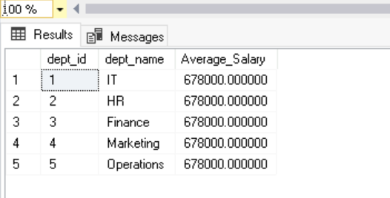

6.Highest and lowest salary per role

This query finds the highest and lowest salary for each job role and it lists all roles and sorts them by highest salary first.

Query

select r.role_id,r.role_name,max(s.salary) as Highest_Salary,min(s.salary) as Lowest_Salary from Job_Roles r
join employees e
on e.role_id=r.role_id
join Salaries s
on s.emp_id=e.emp_id
group by r.role_id,r.role_name
order by Highest_Salary desc;

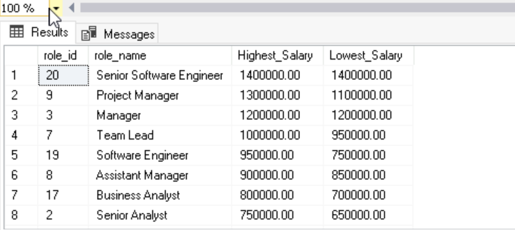

7.Salary vs Performance Correlation

This query retrieves each employee’s salary and their performance rating.It shows the data together for comparison.

Query
select e.emp_id,e.emp_name,s.salary,pr.rating from employees e
join Salaries s
on s.emp_id=e.emp_id
join Performance_Reviews pr
on pr.emp_id=e.emp_id
order by e.emp_id;

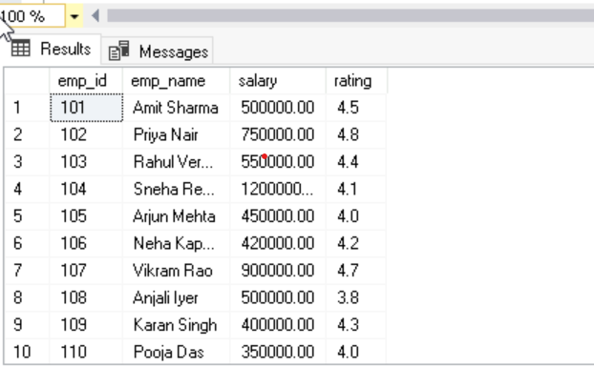

8.Employees below department average salary

This query returns the employee's details whose salary is below the average salary of their department.

Query

select e.emp_id,e.emp_name,d.dept_name,s.salary from employees e
join Departments d
on e.dept_id=d.dept_id
join salaries s
on s.emp_id=e.emp_id
where s.salary<(select avg(s2.salary) from employees e2
join Salaries s2
on e2.emp_id =s2.emp_id
where e2.dept_id=e.dept_id);

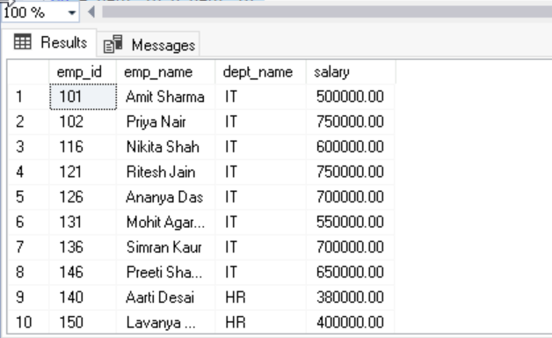

Department Growth

9.Hiring Trend Per year

This query shows the number of employees hired each year.It groups the employees by joining year to display the hiring trend over time.

Query

select year(join_date) as Year,count(*) as 'No of Employees Hired' from employees
group by YEAR(join_date);

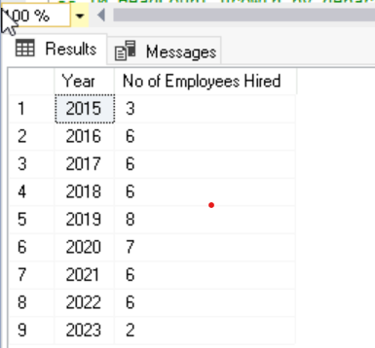

10.HeadCount growth by department

This query shows the number of employees in each department for every year.It helps track headcount growth over time by department.

Query

select d.dept_id,d.dept_name ,year(e.join_date) as 'Year',count(e.emp_id) as HeadCount from Departments d
join employees e
on e.dept_id=d.dept_id
group by d.dept_id,d.dept_name,year(e.join_date)
order by d.dept_id,d.dept_name,year(e.join_date),HeadCount;

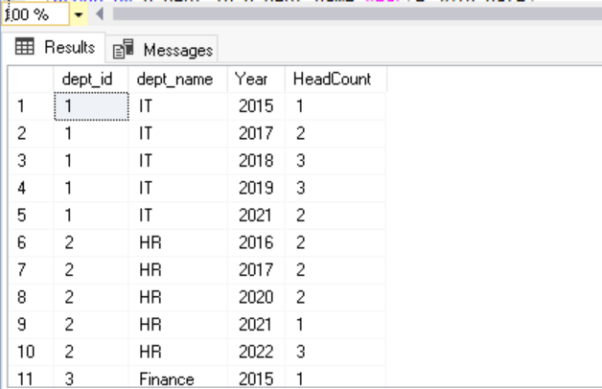

Strategic Insights

11.Employees overdue for promotion

This query lists employees who have high performance ratings (greater than 4).These employees are considered overdue for promotion, and it shows them sorted by rating.

Query

select e.emp_id,e.emp_name,pr.rating from employees e join Performance_Reviews pr
on e.emp_id=pr.emp_id
where pr.rating>4
order by pr.rating desc;

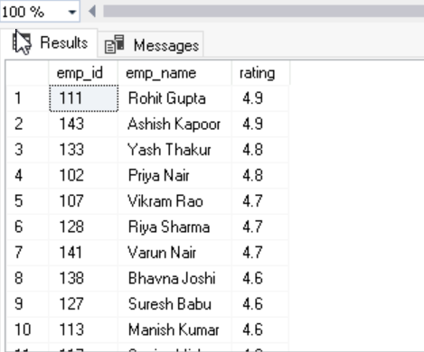

12.High Salary but low performance cases

This query finds employees who have a salary above the overall average but a performance rating below 4.It helps identify high-paid employees with low performance, and results are sorted by salary and rating.

Query

select e.emp_id,e.emp_name,s.salary,pr.rating from employees e
join salaries s
on e.emp_id=s.emp_id
join Performance_Reviews pr
on e.emp_id=pr.emp_id
where s.salary>(select avg(salary) from salaries)
and pr.rating<4
order by s.salary desc,pr.rating desc;

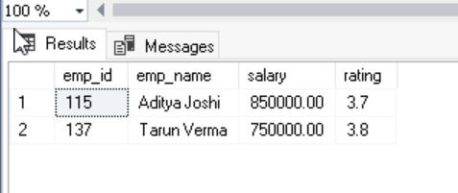

13.Location-wise salary comparison

This query returns the location wise salary distribution.

Query

select l.location_id,l.locatio_name,sum(s.salary) as Salary from Locations l
join employees e
on e.location_id=l.location_id
join Salaries s
on s.emp_id=e.emp_id
group by l.location_id,l.locatio_name
order by Salary desc;

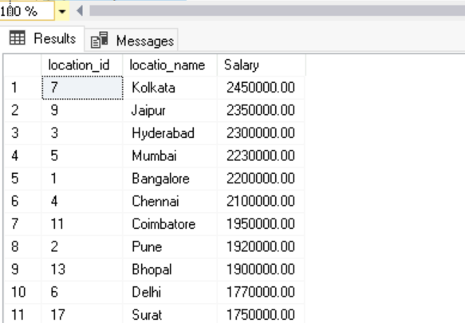

14.Gender diversity ratio

This query calculates the number and percentage of employees by gender.It helps measure the gender diversity ratio within the organization.

Query

select gender,count(*) as total,count(*)*100/(select count(*) from employees) as percentage
from employees group by gender;

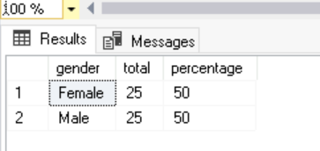

15.Median Salary calculation

This query calculates the median salary of all employees.
It ranks salaries in order, identifies the middle one or two salaries, and takes their average to get the median.

Query

with ranked as(
select salary,
ROW_NUMBER() over(order by salary) as row_num,
count(*) over() as total
from Salaries
)
select avg(salary) as AverageSalary
from ranked
where row_num in ((total + 1)/2, (total + 2)/2);

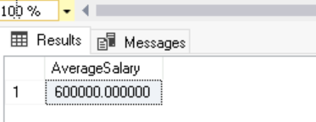

16.Identify leadership pipeline candidates

This query identifies employees who are high performers (rating > 4.5) and have at least 10 years of experience.

Query

select e.emp_id,e.emp_name,pr.rating,datediff(year, e.join_date, getdate()) as Experience from employees e
join Performance_Reviews pr
on e.emp_id =pr.emp_id
where pr.rating>4.5 and
datediff(year, e.join_date, getdate()) >= 10
order by Experience desc;

